**IST370 PRACTICE**

**Worksheet**

**Joining Tables Using Both Implicit and Explicit Join Methods**

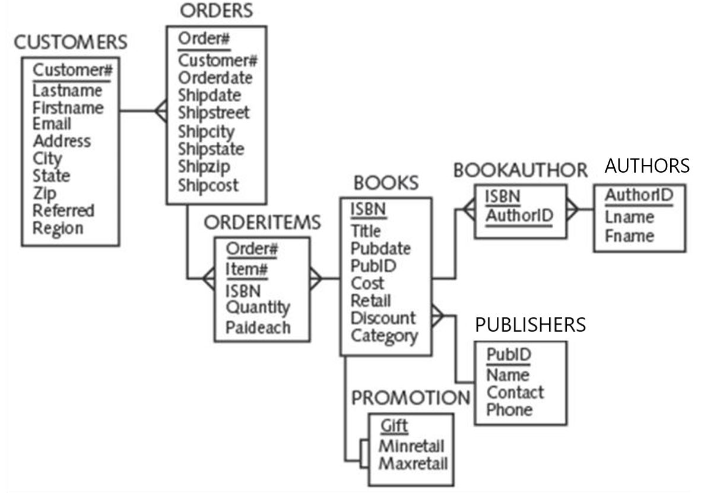

**Query:**

Create a query that identifies those undelivered orders (orders that have not shipped) that were placed in the fourth quarter (i.e., in the months of October, November, and December) of 2015. Sort the results by the date on which the order was placed.

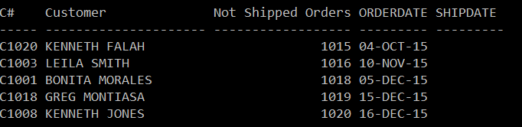

Use the (1) implicit join, (2) explicit NATURAL JOIN, (3) explicit JOIN … USING, and (4) explicit JOIN … ON methods.

**(1) Implicit Join**

SELECT c.customer# C#, c.firstname || ' ' || c.lastname AS "Customer", o.order# AS "Not Shipped Orders", orderdate, shipdate

FROM customers c, orders o

WHERE c.customer#= o.customer#

AND shipdate IS NULL

AND orderdate BETWEEN '04-OCT-15' AND '16-DEC-15'

ORDER BY orderdate;

**(2) NATURAL JOIN**

SELECT c.customer# C#, c.firstname || ' ' || c.lastname AS "Customer", o.order# AS "Not Shipped Orders", orderdate, shipdate

FROM customers c, orders o

AND shipdate IS NULL

AND orderdate BETWEEN '04-OCT-15' AND '16-DEC-15'

ORDER BY o.orderdate;

**(3) JOIN … USING**

SELECT customer# C#, c.firstname || ' ' || c.lastname AS "Customer", o.order# AS "Not Shipped Orders", orderdate, shipdate

FROM customers JOIN orders USING(customer#)

AND WHERE shipdate IS NULL

AND orderdate BETWEEN '04-OCT-15' AND '16-DEC-15'

ORDER BY o.orderdate;

**(4) JOIN … ON**

SELECT customer# C#, c.firstname || ' ' || c.lastname AS "Customer", o.order# AS "Not Shipped Orders", orderdate, shipdate

FROM customers c JOIN orders o ON c.customer# = o.customer#

AND WHERE shipdate IS NULL

AND orderdate BETWEEN '04-OCT-15' AND '16-DEC-15'

ORDER BY o.orderdate;